Analysis of Palestinian Art
Palestinian representation has been used both as a tool to promote cultural art and as a means to objectify characters, often disregarding their personal identities. A closer examination of these portraits reveals their marginalization and exploitation within the emerging national narrative. By discussing the works of prominent artists and analyzing visual imagery, it becomes evident how these visual elements of the Arab figure persisted over time – initially as portrait models and gradually evolving Into representations within applied arts, from the 1920s to the present day.
The Museum of Islamic Art was established in central Jerusalem in 1974 by Vera Bryce Salomons, who studied art and published numerous research books in the field. Salomons, deeply drawn to Islamic art, studied the subject in depth with Professor Meyer. With a vision to bring Palestinians and Jews closer together, she decided to establish a museum focused on Islamic art.
The historian Professor Antighausen Richard was appointed to oversee preservation efforts, while Professor Otto Kurz was named director of research and literature related to this art form. The museum creates an intriguing bridge between Islamic and Jewish art, serving as a broad artistic link between the cultures. For a deeper understanding of the subject, I interviewed key figures in cultures closely connected to Palestinian culture in Israel.
Yariv Egozi has been involved in the fields of art and collecting for over 40 years. He is the owner of Egozi and Aqua Galleries for auctions. Yariv Egozi has taught and continues to teach at schools and colleges specializing in art studies and antique appraisal. He is renowned as an expert with extensive knowledge in Israeli art and art In general. The economic status of Oriental art in the market can be divided into three historical phases:
Early 20th Century (British Mandate Period):
During the British Mandate in Palestine, there was a high demand for art from the Holy Land sacred to Judaism, Christianity, and Islam. Palestinian Arabs, with their traditional appearance, served as visual representations of Biblical and Crusader-era imagery. Most of the demand was for traditional, utilitarian art such as souvenirs and kitchenware. These items often featured depictions of Palestinians as farmers or camel riders, making them highly popular and sought after in Europe and the western United States.
1950s – Post-Establishment of Israel:
After the founding of Israel, the focus shifted to Israeli art, particularly modern painting. Art depicting Palestinian figures was relegated to souvenir shops, while modern Israeli works by artists like Reuven Rubin and Nachum Gutman fetched high prices, maintaining their value even today.
2000s – Global Transformations in Art and Design:
By the 2000s, global trends in home design, textiles, and art began drawing inspiration from minority and tribal art. The international art industry started recognizing the power of Eastern symbols, gradually increasing the value of such works, especially in popular art circles.
During this period, young Palestinians in Israel began attending art academies and producing modern art that integrates their traditions and Muslim faith.
Contemporary Market:
Today, two Palestinian artists have achieved significant recognition, with their works valued at tens of thousands of shekels:
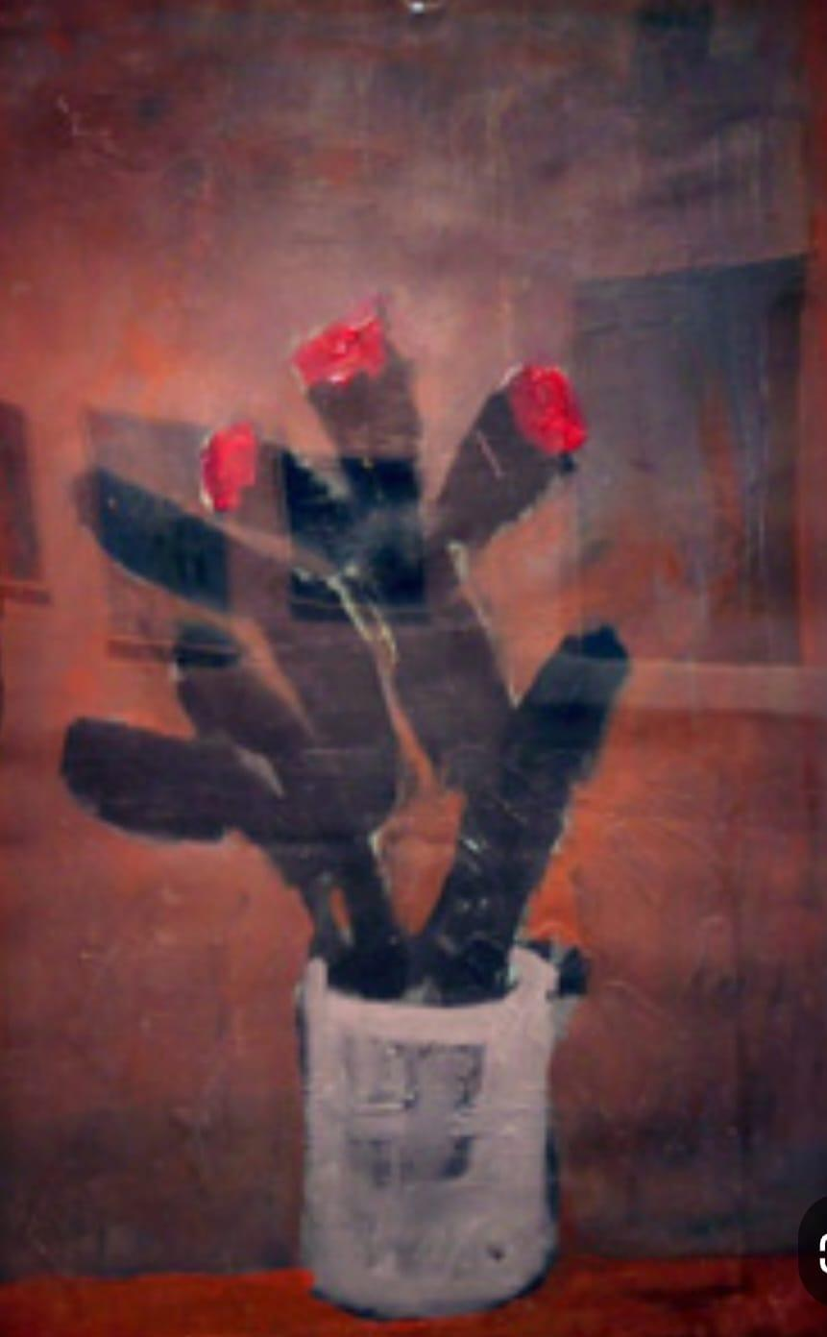
The Cactus - Assam Abu Shakra 1961-1990
Assem Abu Shakra: Known for his Cactus motiv, symbolizing the uprooted individual.
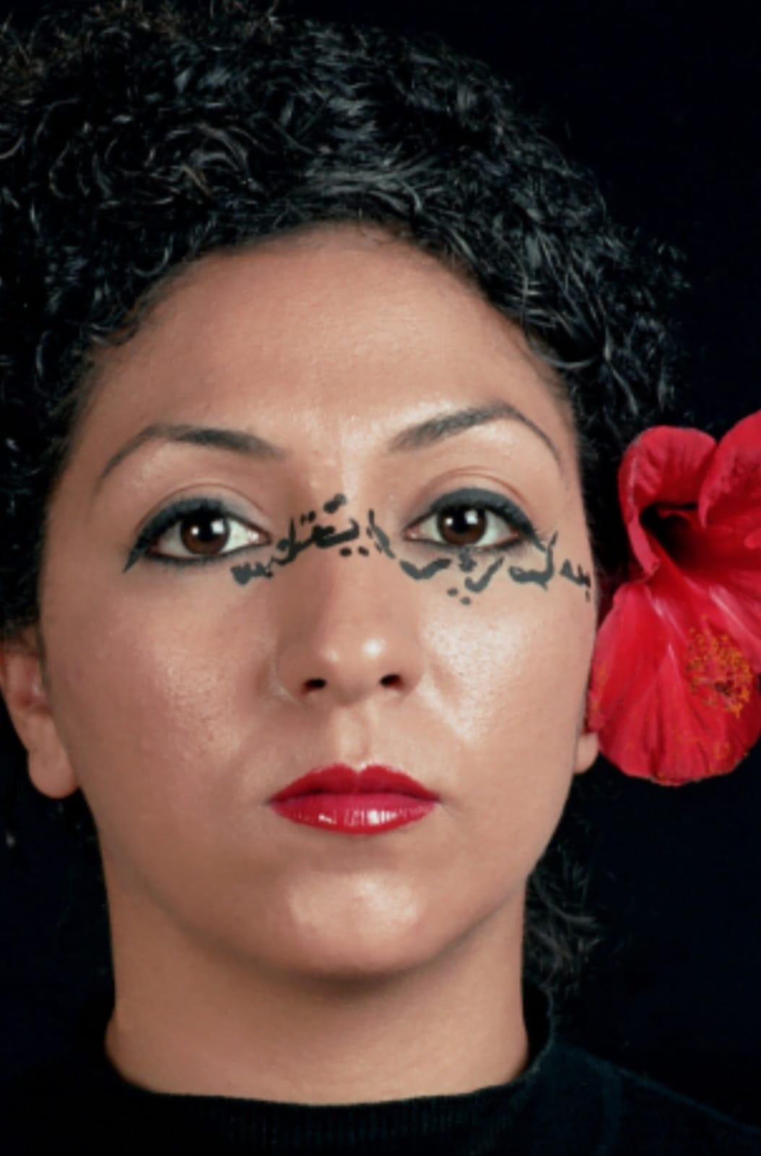
Anisa Askar 1979
Anisa Ashkar: Combines Arabic calligraphy with personal and religious verses on her face as a canvas.
Both artists are highly sought after by art dealers in Israel and abroad.
Does Politics Affect the Prestige of Palestinian Artists?
Answer: Yes, politics has a profound impact on their status. It’s a delicate thread connecting political circumstances with artistic talent. Artists seeking to succeed must present their work through meaningful processes rather than pure protest. While protest art has a place in institutional museums, it doesn’t attract much demand from private collectors or consumers.
What Is Your Opinion on Consuming Oriental Art?
Answer: Oriental art should be evaluated based on its quality and not merely as a cultural symbol. Such an approach will elevate its value even further In the future.
Question: Does politics affect the prestige of Palestinian artists?
Answer: Yes, politics significantly impacts their status. It is a delicate thread connecting the political situation with artistic talent. Artists seeking success must present their work through a meaningful process, not merely as protest. While protest art finds a place in institutional museums, it is less sought after by consumers and private collectors.
Question: What is your opinion on the consumption of Oriental art?
Answer: Oriental art should be judged by its quality, not just as a cultural symbol. This perspective will enhance its artistic value over time.
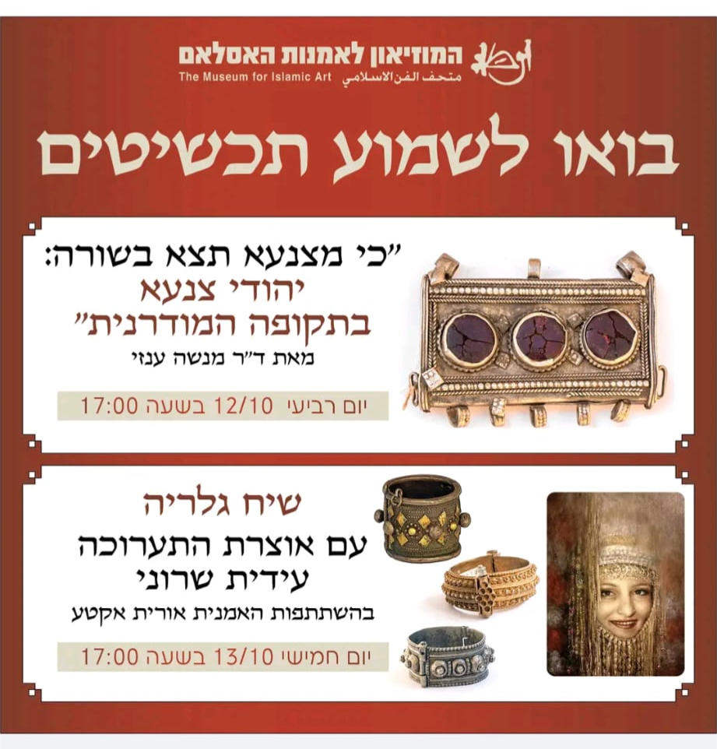
Orit Akta Hildesheim (b. 1970) lives and works in Tel Aviv. She studied under the artist Meir Nativ and has exhibited solo shows both in Israel and internationally. Notably, her work was featured at the Tel Aviv Museum of Art following her receipt of the 2011 Haim Shiff Prize for Figurative-Realistic Art.
“Before I began exploring Yemeni culture, I often heard people describing me as an "Arab." It made me uncomfortable, especially when even my husband said it. However, as I started delving into the culture I came from, revisiting memories of my grandmother's house – the smells of the food, the prayers, and that traditional clothing – I realized the connection between my Jewish and Arab identity is genuine. We, Yemeni Jews, grew up in the same places as Muslims, and this bond Is unbreakable.
Even though Jews were a minority and sought to distinguish themselves, the similarities in customs, clothing, and language are undeniable. Today, when I talk to my Arab friends, we discover many shared connections – in words, beliefs, and even in practices like using amulets against the evil eye.”
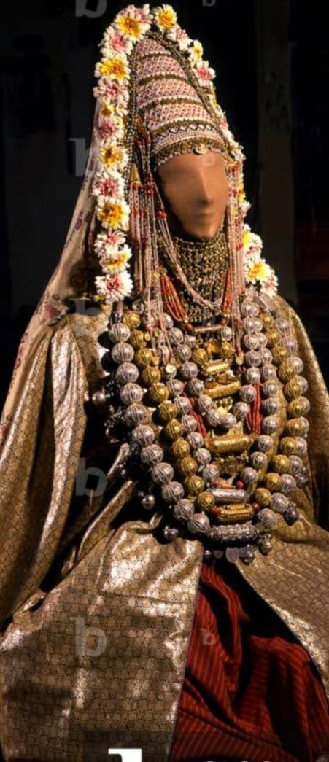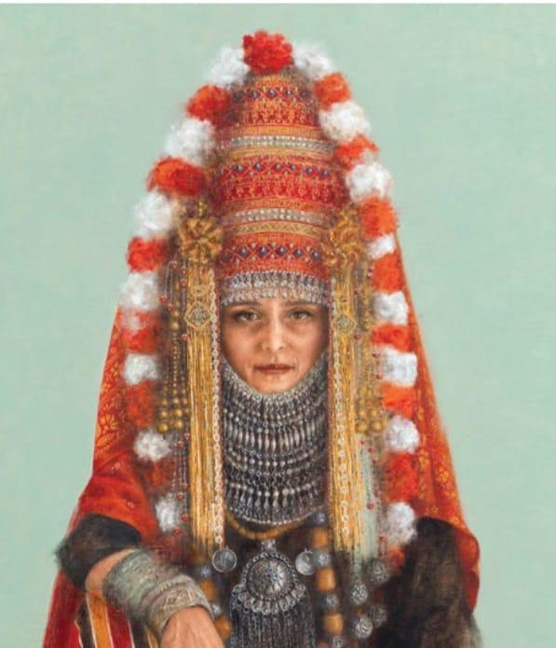
On the right, a Yemenite Jewish bride. Orit Akta. On the left, a model of a Yemenite Muslim bride.
The selected works vary in size and techniques, including sketches, oil paintings, engravings, and applied arts such as decorative plates, bas-reliefs, posters, and playing cards. This collection provides a comprehensive perspective on how appropriation and exclusion were depicted in Israeli artistic spaces in the early 20th century. Each piece is presented with its title, date, background, and characteristics, emphasizing its historical context, central messages, and recurring motifs.
Prominent themes include camels, palm trees, arabesque designs, desert landscapes, and water jars. While Arabs and Yemenites were often depicted with similar traditional clothing and associated with similar landscapes and objects, distinctions can be observed. Arabs were often portrayed as part of the environment, whereas Yemeni portraits focused on the individual - with unique traits such as slender physiques and curled side locks.
Hanania Qurash, a 72-year-old father of four, has been managing the Yemenite Art Museum for seven years. He holds a bachelor’s Degree in Middle Eastern studies and a master’s Degree in religious studies from Tel Aviv University.
The museum attracts a diverse audience: approximately 30% of visitors are of Yemenite descent, while the rest include individuals from various backgrounds, including Palestinian Arabs. The museum combines Jewish and Muslim cultures, although most exhibits are attributed to Jewish artists.
Qurash also led tours at the museum for two years, hosting groups from Tel Aviv University’s Arabic and religious studies departments. These tours focused on the socio-theological encounters between Yemeni Arabs and Jews.
Palestinian Iconography
Palestinian iconography is characterized by the extensive use of agricultural motifs as powerful symbols of the profound connection to the land and national identity. The orange and the orchard hold a central place in this symbolism, representing nostalgia for an idyllic past and hope for a utopian future. Artists like Sliman Mansour, from the post-1948 generation, created works in the 1970s and 1980s depicting Palestinian farmers in traditional attire carrying or picking oranges, bathed in golden, warm light. Mansour viewed these depictions as an image of "what life could look like without occupation," reinforcing and affirming the Palestinian connection to the land, place, and traditional cultural roots.
The olive tree is another prominent symbol, representing a deep and enduring bond with the land. Artists like Walid Abu-Shakra created drawings of olive trees in specific locations, expressing an intimate connection to place and a sense of loss. Khalil Rabah replanted olive trees from Ramallah in Geneva, and in later works, reflected the tree trunks in his own body, emphasizing the identification of the Palestinian individual with the olive tree.
Palestinian artists also use citrus fruits as symbols of resistance and political struggle. Adnan Zubeidi created a piece showing a fist crushing an orange and "squeezing" it into a mold shaped like the Star of David. Jumana Emil Abboud produced a film about "smuggling" lemons from the Galilee to Ramallah, reflecting the absurdity of the Palestinian condition.
Contemporary artists employ these motifs in more complex ways. Larissa Sansour presents an olive tree in a modern urban environment, exploring concepts of rootedness and displacement. Raafat Hattab depicts a man watering an olive tree in Rabin Square, Tel Aviv, raising questions about longing and belonging. Vera Tamari combines photography of a real olive tree with small clay sculptures of olive trees, evoking questions about authenticity and representation.
Sliman Mansour creates "loaves of bread" from soil and water, symbolizing a connection to the land but also a sense of loss. Mona Hatoum uses distorted kitchen utensils to examine concepts of home and exile, creating a sense of alienation and disorientation. Rania Bshara employs food products as raw materials for her works, transforming them into inedible forms, exploring personal and national identity.
Palestinian iconography reflects an ongoing struggle over identity, place, and belonging. Through the use of agricultural symbols and food, artists express complex ideas about connection to the land, loss, and hope. These works reflect the tension between past and future, tradition and modernity, and current reality and national aspirations. They serve as a powerful tool for expressing Palestinian identity and grappling with the complex political and social realities.
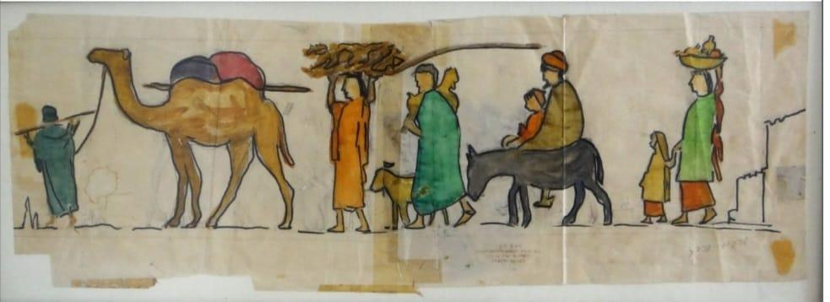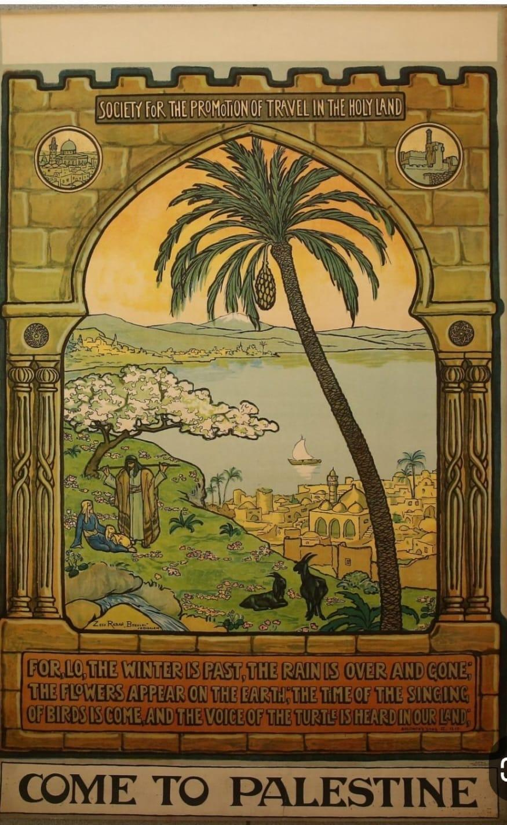
The Artwork: "Come Visit the Holy Land" – 1920 – Ze’ev Raban
Artwork Description: The poster "Come to Palestine" depicts an idyllic landscape with a lake at the center, surrounded by mountains, hills, and a clear sky. On lush green land stand two figures in Oriental attire: the man, dressed in a tunic, striped cloak, and a wide belt, stands next to the seated woman, who is in a dress with a long headscarf. Both are positioned in front of a large tree. The woman holds a white kid in her lap, while two black kids stand beside a small water source. To the right, at the base of the hill where the figures are located, lies a settlement with Middle Eastern-style houses, domed roofs, and a minaret. A tall palm tree stands on the far right, spanning the height of the artwork. The poster is framed with decorative columns resembling the stone walls of the Western Wall in Jerusalem, with an invitation to visit the Holy Land detailed at the bottom.
Analysis: The sky is a soft, deep yellow, casting a special light. The mountains are painted in pastel greenish-blue, hinting at the beauty lying beyond. The lake is a serene blue, with a white-sailed boat gliding on its calm waters. The houses, similarly shaped and colored in a yellowish cream, create an atmosphere of a primordial place. The foreground hills are lush with medium-green vegetation. The tree with white blossoms (perhaps an almond tree) symbolizes purity, growth, and abundance. The seated woman in a blue dress wears a white headscarf and pets a white kid. Beside her stands a broad-shouldered man holding a staff, possibly for herding; he wears a light-blue tunic and earthy striped cloak, with the brown color echoed in the poster’s frame, emphasizing the land and historical stones. The kids in the painting are black—a clear symbol of the diversity of the Holy Land. The tall, pristine palm tree that divides the composition bears a bunch of dates, symbolizing fertility and nature.
As a vintage advertisement, the poster invites viewers to visit the Holy Land. The scene chosen is the city of Tiberias with the Sea of Galilee, highlighting the abundance of the land, which was known by Christian pilgrims as arid. The figures evoke a biblical scene, with the man holding a shepherd’s staff, reminiscent of biblical references like Moses and King David. Looking deeper, one can find Christian motifs, such as the choice of the Sea of Galilee and the "good shepherd" theme, subtly suggesting to Christian tourists the unique value of visiting the Holy Land.
About the Artist: Born in Poland in 1890, Ze’ev Raban trained in art academies in Munich and Paris and was a multidisciplinary artist who worked in painting, sculpture, and graphic arts. In 1912, he immigrated to the Land of Israel upon an invitation from Boris Schatz to teach at the Bezalel School of Art. Raban’s artistic activity significantly influenced the unique style of the school, creating Jewish art interwoven with Jewish symbols, often reflecting the biblical spirit of the Land of Israel. Raban illustrated numerous

"Come to Palestine" – A 1930s Poster by Alice Abramson
Poster Description: The poster, rendered in shades of cream, orange, red, and black, portrays an Arab figure seated in a black and white striped robe, wearing a red and white keffiyeh, and holding a staff. Above him stands a Jewish figure in a suit with a white kippah, bearded and with sidelocks, reaching toward the Tower of David and the walls of Jerusalem. To the left, a donkey is illustrated, with a black tent roof above both figures. Both characters face the viewer directly. The top of the poster features the English inscription, "Come to Visit Palestine." Along the bottom, there’s a decorative strip with a repeated motif of an orange-colored camel caravan.
Artwork Analysis: The uniqueness of this poster lies in the artist’s choice to depict and unite both Jewish and Palestinian identities. In Abramson's view, the holy city of Jerusalem has room for both the Arab figure sitting under the tent and the Jewish figure standing beside him. They coexist, each bearing their own form of prayer—each with their distinct traditions and symbols—on the same land. This rare poster embodies a religious and cultural integration that is seldom seen, creating a visual narrative of shared heritage.

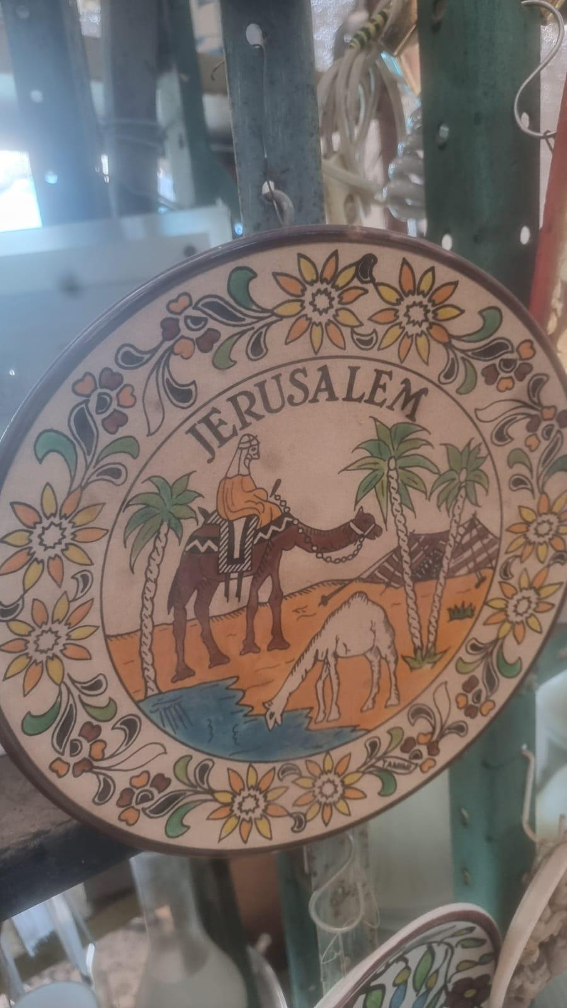
Ornamental Plate – Palestinian Rider on a Camel
Description: This 30 cm round plate is painted in two concentric circles. In the central, larger circle, we see a depiction of a yellow desert landscape with a brown-and-white striped tent in the background, three date palms, a small pond, and a small white camel drinking from the water. In the distance, a Bedouin man, dressed in a yellow tunic and white keffiyeh, rides a large brown camel, equipped with a decorated saddle and colorful cushion. The style of painting is naive and flat, with defined black outlines and solid colors, avoiding shading. Above the central circle, the word "JERUSALEM" is inscribed. The plate’s outer rim is decorated with a repetitive floral ornamentation, emphasized with black outlines. The artist used only blue, yellow, green, brown, and white.
The Pal-Bell company, founded by Maurice Ascalon and Abraham Kom in 1939, produced both utilitarian and decorative metal and ceramic items. Known for creating decorative Judaica and artistic objects from copper and brass, Pal-Bell primarily sold its products to tourists in Israel and abroad. The company’s designs drew from popular European styles of the time, including Art Deco and Viennese bronze crafts. Although it closed in 1950, Pal-Bell’s products remain valued in Israeli art history, often associated with the "Israeliana" style.
Analysis: The desert themes—tents, camels, wanderers, water sources, and nomadic life—echo various Biblical narratives. For example, the desert, wanderer, and water are referenced in Exodus 15:22, where Moses leads Israel through the desert for three days; camels in Genesis 24:11, as they rest by a water well; and the tent in Genesis 27:25, describing Jacob as a "man of the tents." The plate’s artistic theme is an interpretation connecting these Biblical landscapes to contemporary holy land imagery. The artist chose a Palestinian figure, riding a camel through the desert, as a visual representation of the Biblical figure associated with the Israelites’ journey in the Sinai Desert.
In the inner circle, the predominant yellows and browns evoke a desert landscape, reminiscent of colors on physical maps where brown indicates mountains and yellow represents deserts. The surrounding floral designs in the outer ring, executed in an arabesque style, resemble the Armenian ceramics that are widespread in East Jerusalem.

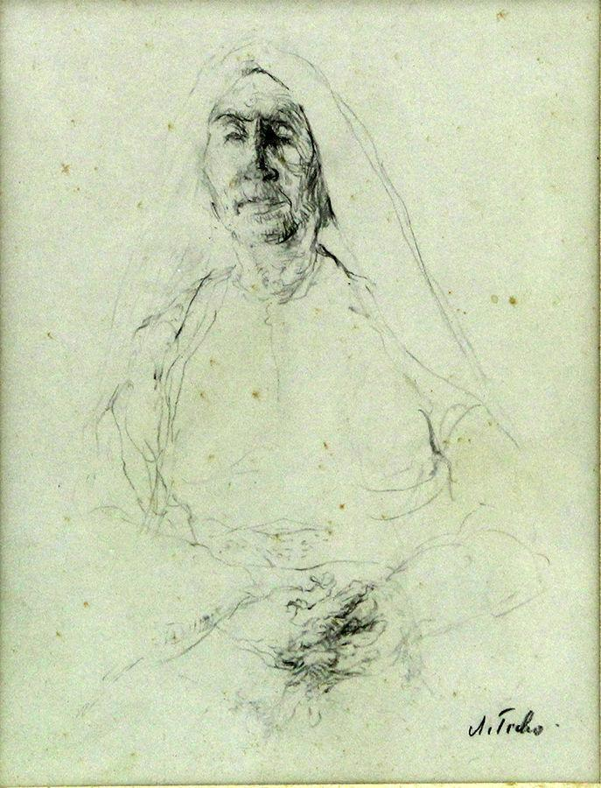
Portrait of an Elderly Arab Woman, 1940, Pencil on Paper, Size: 15 x 25 cm

Anna Ticho was known for her mastery of pencil, ink, and charcoal drawings. After her husband’s death, her art evolved, incorporating watercolor to add color to her work, yet she remains celebrated for her pencil sketches, especially of Jerusalem landscapes. In this particular drawing, Ticho captures an elderly Arab woman, accentuating her face and hands with strong, defined lines, while her body is depicted with softer, more abstract strokes. The woman’s face, marked by fine wrinkles, shows a slight frown in her brows, her chin raised to exude an impression of strength. Her neck is also etched with subtle wrinkles. Dark lines emphasize the right side of her face, and her clasped hands, also delicately wrinkled, are shaded to suggest age and character.
A loosely draped scarf rests over her head, with a few strands of hair visible, typical of traditional Arab women’s headwear. Her body appears broad, and faint outlines of her chest extend almost to her waist, hinting at weight and stature. The woman’s seated position is implied, but the drawing includes no background elements, suggesting Ticho's intent to focus solely on the model herself as the central theme. While the identity of the model remains unknown, the portrait hints at a bond of trust between artist and subject—perhaps rooted in a relationship with Dr. Ticho, her husband, as a potential caretaker for the model or her family, allowing the woman to pose for this intimate portrayal.

The Artwork: "Come Visit the Holy Land" – 1920 – Ze’ev Raban
Artwork Description: The poster "Come to Palestine" depicts an idyllic landscape with a lake at the center, surrounded by mountains, hills, and a clear sky. On lush green land stand two figures in Oriental attire: the man, dressed in a tunic, striped cloak, and a wide belt, stands next to the seated woman, who is in a dress with a long headscarf. Both are positioned in front of a large tree. The woman holds a white kid in her lap, while two black kids stand beside a small water source. To the right, at the base of the hill where the figures are located, lies a settlement with Middle Eastern-style houses, domed roofs, and a minaret. A tall palm tree stands on the far right, spanning the height of the artwork. The poster is framed with decorative columns resembling the stone walls of the Western Wall in Jerusalem, with an invitation to visit the Holy Land detailed at the bottom.
Analysis: The sky is a soft, deep yellow, casting a special light. The mountains are painted in pastel greenish-blue, hinting at the beauty lying beyond. The lake is a serene blue, with a white-sailed boat gliding on its calm waters. The houses, similarly shaped and colored in a yellowish cream, create an atmosphere of a primordial place. The foreground hills are lush with medium-green vegetation. The tree with white blossoms (perhaps an almond tree) symbolizes purity, growth, and abundance. The seated woman in a blue dress wears a white headscarf and pets a white kid. Beside her stands a broad-shouldered man holding a staff, possibly for herding; he wears a light-blue tunic and earthy striped cloak, with the brown color echoed in the poster’s frame, emphasizing the land and historical stones. The kids in the painting are black—a clear symbol of the diversity of the Holy Land. The tall, pristine palm tree that divides the composition bears a bunch of dates, symbolizing fertility and nature.
As a vintage advertisement, the poster invites viewers to visit the Holy Land. The scene chosen is the city of Tiberias with the Sea of Galilee, highlighting the abundance of the land, which was known by Christian pilgrims as arid. The figures evoke a biblical scene, with the man holding a shepherd’s staff, reminiscent of biblical references like Moses and King David. Looking deeper, one can find Christian motifs, such as the choice of the Sea of Galilee and the "good shepherd" theme, subtly suggesting to Christian tourists the unique value of visiting the Holy Land.
About the Artist: Born in Poland in 1890, Ze’ev Raban trained in art academies in Munich and Paris and was a multidisciplinary artist who worked in painting, sculpture, and graphic arts. In 1912, he immigrated to the Land of Israel upon an invitation from Boris Schatz to teach at the Bezalel School of Art. Raban’s artistic activity significantly influenced the unique style of the school, creating Jewish art interwoven with Jewish symbols, often reflecting the biblical spirit of the Land of Israel. Raban illustrated numerous

The Painting: Arabs in a Village in Palestine, 1925 – Ze’ev Raban, Paper, 60 x 20 cm
Description: This rectangular, naive-style painting is done in markers, with flat colors and black outlines defining the shapes. The painting is colorful and divided by a black line marking a path upon which the figures walk. The eight Middle Eastern figures are portrayed in a long procession: two women, three men, two children, a camel, a kid goat, and a donkey. Their faces lack detail, and they wear colorful clothing, with an ochre-yellow camel, a black donkey, and a white kid goat standing out among them.
The line is led by a man in a blue tunic holding a pole across his shoulders, leading a camel by a rope. The camel carries poles and two sacks on its back. Behind the camel, a woman in an orange dress balances sacks on her head. Following her is a woman in a light blue tunic with a small child on her back, accompanied by a white kid goat. Behind them walks a donkey bearing two riders, an adult in brown attire and a child in an orange shirt. Lastly, a woman in a two-part dress—turquoise on top, orange on the bottom—holds a child with one hand while balancing a bundle on her head with the other.
Analysis: The artist has depicted what appears to be a family caravan, likely on their way home to the village after a journey. Raban reveals their modest possessions: animals and bundles. The lack of facial features allows for a more collective representation, where the individuality of the characters gives way to a communal identity, as seen in a similar approach by the painter Shmuel Shlezinger, who expressed collective rather than individual identity in his family paintings.
The flat color choices and absence of facial details may be intended to emphasize the conceptual scene over individual identities. A sense of familial hierarchy emerges, with the male figure leading the line and others following, suggesting trust and unity within the family structure. The black outline dividing the ground from the sky lends stability, grounding the figures on "solid earth," evoking biblical associations of long journeys and family migrations in the Holy Land. This imagery resonates with the stories of Abraham’s journey with his family to Canaan (Genesis 12:1), Jacob’s departure to Haran with his family and possessions (Genesis 28:10-15), and Esau’s migration with his family and household (Genesis 36:1-3). The depiction draws from these familiar narratives of familial migration and settlement in the biblical landscape, connecting the portrayed characters to both a physical and symbolic ground of the Holy Land.

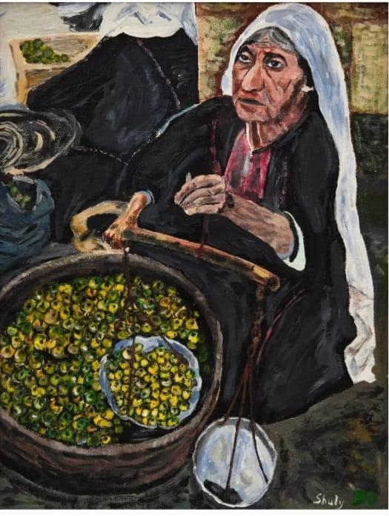
The Painting: Apple Seller by Shuli Haimzon, 1956, Oil on Canvas, 40 x 50 cm
Description: Shuli Haimzon’s painting captures a scene from village life, presenting a Palestinian Arab woman selling apples. The woman, seated and wearing a long white headscarf, is dressed in a black dress adorned with traditional Palestinian embroidery in red hues across the upper front section. She holds a balance scale in her left hand, with the left plate filled with fruits, while the right plate hangs empty. A large container of small green and yellow apples sits in front of her. Her dark, wrinkled face suggests an older age, and her gaze, slightly raised, seems focused intently, possibly observing customers. Behind her, faint outlines suggest another Arab woman seller.
Analysis: Haimzon’s work explores everyday village life, focusing on people, places, and the intricate layers of the diverse communities around her. This scene reflects the common role of Palestinian Arab women in agriculture, from planting and growing to harvesting and selling produce, as seen in 1930s artworks, like Moshe Castel’s “Olive Harvest,” where Arab families and women are portrayed gathering olives.
The presence of the apple seller also echoes themes seen in 1940s works by artists like Bracha Tzfira, who captured laboring women in her abstract painting “Arab Women in the Field.” The traditional dress and movements of the women show their bond with the land and its cultivation. Nachum Gutman, another influential artist, also documented the agricultural work of Palestinian women in the public sphere.
Haimzon’s portrayal of the apple seller suggests a timeless representation of labor, where the familiar balance scale, well-worn face, and steady gaze invite viewers to recognize both the resilience and enduring presence of these women in the everyday scenes of village markets.

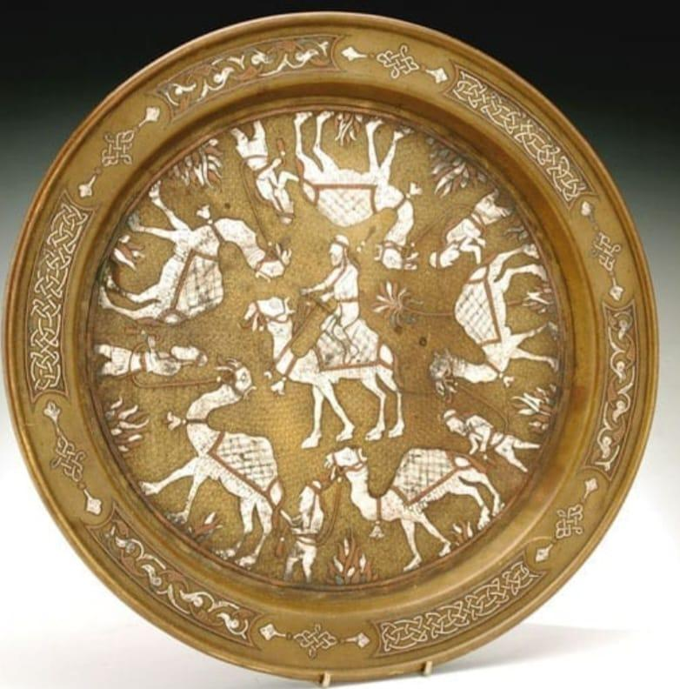

Artwork: Brass Coffee Serving Plate with Damascus Ornamentation, Jerusalem, 1930
Artist: Alfred Salzmann, an Austrian Jew, immigrated to Palestine in 1921, settling in Jerusalem. As a teacher in Bezalel’s Metal Work Department, he aimed to foster coexistence through craftsmanship, employing both Arabs and Jews. In Jerusalem’s Baka neighborhood, Salzmann acquired a home on a four-dunam plot, establishing a factory that produced practical items such as storage boxes, collection tins for the Jewish National Fund, and decorative art objects with Middle Eastern and biblical motifs, including trays, plates, ceramic tiles, and vases.
Description of the Piece: The round brass plate, 33 cm in diameter, is inlaid with silver and copper threads. The rim features intricate arabesque designs and twisting plant motifs, while the center relief showcases Palestinian Arabs dressed in traditional keffiyeh and robes. Some figures ride camels, while others stand nearby, surrounded by desert-evoking date palms. Serving as a kitchen and hosting accessory, the plate is a period marker, reflecting the cultural grounding of Palestine in the 1930s. Despite the British presence and Western influences, the art from this period emphasized the land’s rich Mediterranean and biblical heritage sacred to Judaism, Christianity, and Islam.
Salzmann’s choice to depict Palestinian Arab figures, the desert, and date palms underscores Bezalel’s founding vision: to build a connection with the land of the Bible and its nomadic history, reminiscent of the Israelites' desert journey. This coffee plate exemplifies an approach that, while practical, is deeply rooted in cultural symbolism, blending local traditions with narrative art.

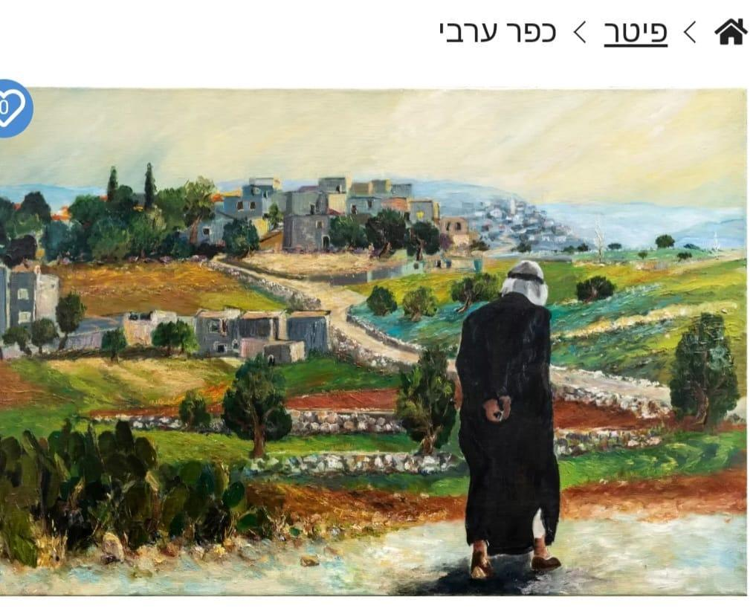
Arab Man Overlooking the Village" - Signed by Peter, Other Details Unknown"
Description of the Painting: This painting depicts the outskirts of a village built on three terraced levels. In the background, faint grayish shapes suggest distant buildings, while in the farthest terrace, clear, flat-roofed structures stand surrounded by Mediterranean greenery such as cypress and olive trees. The second terrace features a row of closely positioned houses, and the closest terrace has cactus bushes. At the center of the painting, a long path is lined with characteristic regional stone ruins. A male figure stands on the main path, bent forward, dressed in a black galabia and a white keffiyeh, holding prayer beads, and appears to be walking toward the village.
The painting’s color scheme and brushstrokes are in line with the Impressionist style, featuring a bright palette and a sense of natural light. The sky is a soft cream-blue, lending a pastoral tranquility. The painting repeatedly uses shades of green, earthy ochre, and reddish sienna. The figure's black galabia contrasts sharply, visually connecting with the distant black trees, while the grayish stones along the terraces and pathway add textural highlights throughout the landscape.
Analysis: The painting conveys a photographic, realistic impression. The village's authenticity, with its stone fences, sand mounds, and scattered stones, brings an emotional depth to the scene. The color scheme does not dispel an underlying sense of desolation, highlighted by the solitary figure of the Palestinian Arab man on the edge of the village, evoking isolation and contemplation. many Palestinian Arabs live in villages across the land, feeling a deep connection to the soil and the olive groves, symbolizing their emotional and symbolic ties to the place. After 1948, many Arab families fled and left their lands. The bent figure in the painting, with his head seemingly bowed, prayer beads in hand, and a cactus by his side—a symbol of endurance—suggests his patience, hinting to the viewer that, with time, he believes he will return to his lands in the various villages.

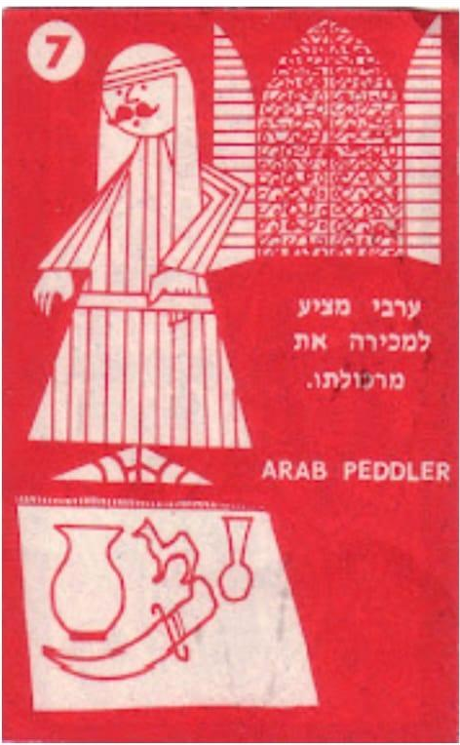
Cards Game "Jerusalem of Gold" by Ha-Chaim Publishing, 1968
Description: The "Jerusalem of Gold" game is a social board game featuring illustrated cards, published after the Six-Day War and the reunification of East Jerusalem. The game highlights diverse sites, including Jewish landmarks like the Western Wall, as well as mosques, churches, tombs, and ancient ruins. Designed for the whole family, it aims to introduce players to the historical and culturally significant sites of Jerusalem. Card number 7, titled "Arab Selling His Wares," depicts an illustrated Arab vendor.
Illustration Description: The card illustration is rendered in white on a red background. On the left, a Palestinian Arab figure is depicted in a striped galabia and a keffiyeh, with sandals on his feet and a mustache on his face. To his right is an arched window, characteristic of Islamic architecture, with the Hebrew title "Arab Offering His Wares for Sale" and an English subtitle "Arab Vendor." At the bottom of the card are objects associated with Eastern culture in the region: a large jug, a smaller jug, a dagger, and a camel.
Analysis: The card’s color scheme of red and white creates a striking visual contrast that draws the viewer’s attention. The central Arab figure, surrounded by objects with Oriental traits, reflects elements of Palestinian and Arab identity. The arched window subtly emphasizes the vendor's cultural background, while the objects depicted, often seen as souvenirs from

Olive Wood Cigarette Storage Box - Bezalel Artists, 1912
Description: This olive wood box measures approximately 10 by 15 cm, similar in size to a standard cigarette box today. It is coated with a yellowish lacquer, featuring dark yellow and mustard tones. The design is outlined in black. The central illustration depicts a figure riding a camel while playing a flute, with another figure leading the camel by a rope. To the left of these figures is an illustration of a palm tree.
Analysis: Cigarette storage boxes were popular at the time, serving not only a practical purpose but also a decorative one. The craftsmanship and ornamentation of such items reflected the significance of applied art, making them common accessories for many smokers. This particular box, made from local olive wood, symbolizes the native materials used for carving, sculpting, and producing items at Bezalel and other art workshops in the first half of the 20th century.
The designer chose to portray an Arab figure on a camel, which serves as an authentic representation of the Holy Land. The camel, desert landscape, and rider are integral components of the visual identity of the region. The use of these elements likely continues the design philosophy that intertwines biblical narratives, particularly the stories of the Israelites' wanderings in the desert. Upon their arrival in the land, palm trees with dates, a symbol of fertility and bounty, are often referenced in connection to the land of Israel.
As seen in other works, the Oriental narrative promotes the symbolism of applied art and cultural representation, with this box serving as a tangible example of Palestinian Arab identity in the context of the artistic expressions of the time.
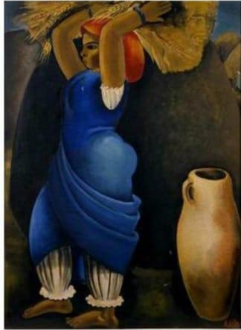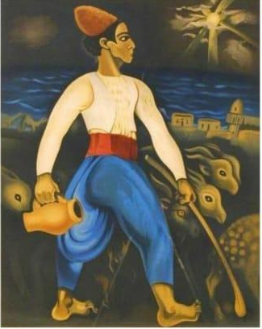
Carrying the Sheaf and Jug by Nahum Gutman, 1926; Goat Herd by Nahum Gutman, 1926
Overview: These paintings by l Nahum Gutman reflect symbols of the land of Israeand the Middle East.
1. Carrying the Sheaf
In "Carrying the Sheaf," the central figure is a Palestinian Arab woman carrying bundles of sheaves in her hands. To her right is a large jug. The woman's prominent stature dominates the composition, highlighting the celebratory aspect of agricultural work and symbolizing renewal. The depiction of her as a laborer underscores the significance of manual labor and settlement in the land.
Color Description: The background colors are dark earthy tones, with hints of blue sky peeking through. Her face, the sheaf on her head, and the jug are painted in mustard yellow. She wears a white short-sleeved blouse and a blue dress, with white trousers and a red scarf on her head.
2. Goat Herd
In "Goat Herd," a Palestinian Arab herder is depicted wearing a white shirt, a vest, blue trousers, and a red belt. In his right hand, he holds a stick, while in his left, he carries a jug. Behind him, against a dark background, a herd of goats can be seen, with a sparse landscape featuring a few Arab houses along the coast, and faint sunlight breaking through the dark skies.
The colors used in both paintings resonate with characteristics of Christian art—red, blue, and white. This may suggest that Gutman, originally from Serbia, was influenced by classical European art, where these colors carry specific meanings: red often symbolizes the crucifixion of Jesus, representing emotional contexts of warmth, passion, and suffering; blue evokes Christ's walk on the waters of the Sea of Galilee, faith, and the Virgin Mary's garments; and white symbolizes Christ's light and ascension.
Analysis: Nahum Gutman's use of these colors bridges local art with global influences, capturing manual labor and daily life in the Holy Land while being influenced by European painting styles, such as naïve and cubist art.
The jug, appearing in both works, serves as a central element, essential for daily life. The imagery of the jug, influenced by both European and local artistic traditions, finds a deep expression in Israeli art, becoming a symbol of the new and biblical land of Israel without specific religious context. The jug exemplifies how visual imagery can reflect and shape cultural and national perceptions, as seen in Gutman's portrayal of Palestinian Arabs as integral to the land's development.
Gutman views Palestinian Arabs as essential to the growth of Israel, analogous to the necessity of jugs in human daily life.

The 19th century marked an era of unprecedented European interest in the Holy Land and the Middle East, a fascination vividly mirrored in the literature and art of the time. Travelers, scholars, and Western artists arrived in the region in droves, driven by an intense desire to explore and document the "Land of the Bible." Many, seeking to immerse themselves in the environment and experience the East authentically, adopted local attire and, at times, even a complete Muslim way of life. This phenomenon sparked a significant rise in portraits depicting Westerners in Eastern attire, including notable figures like James Silk Buckingham, painted by Henry William Pickersgill, and Johann Ludwig Burckhardt. Artists themselves also engaged in this trend, creating self-portraits in traditional garb, which became both status symbols and promotional tools for their travel writings.
Simultaneously, a major trend in documenting Biblical landscapes emerged, driven by the increasing popularity of Bible studies in Europe and the strong desire to connect Biblical texts with geographic reality. The Bible, more accessible than ever due to translations and the invention of the printing press, had become an integral part of European Christian culture. Travelers sought out familiar places in the land from their childhood stories, and many remarked that the geography of the Holy Land became more familiar to them than that of their own surroundings.
As a result, illustrated travel books, illustrated editions of the Bible, and impressive collections of landscape paintings from Israel and surrounding areas were produced. These illustrations included not only depictions of events and holy sites but also landscapes, maps, architectural sketches, and ethnic types, providing a comprehensive picture of the land and its inhabitants. This fascination was also evident in the publication of dedicated travel guides, such as the 1824, The Modern Traveller, the first in a popular series of global geography books.
Toward the end of the 19th century, various painters and artists came to Israel to paint the Holy Land, especially Jerusalem. Some arrived under the auspices of the English Church, others as part of research missions from America and France, while still others came independently. They painted the landscapes out of religious and spiritual motivations, immortalizing its sites and people. The Holy Land, a source of significance for the three major religions for the past two thousand years, had witnessed struggles, wars, and conquests. To these artists, it embodied the Biblical promise and the dawn of human history.
Upon arrival, these painters felt that the Middle East, and Israel in particular, had not changed much from the Biblical descriptions. The local Arab population and nomads, with their vibrant traditional attire reminiscent of Biblical descriptions, became authentic models for artists like David Roberts (1835), William Turner (1833), Butler (1845), and others. The solid and confident presence of Palestinian Arabs provided an accurate backdrop to the powerful and wild desert landscapes, telling an important historical story spanning thousands of years.
In 1882, when Yemeni Jews arrived in Jerusalem, their appearance—Middle Eastern dress, physical features, skin color, and speech—resembled Arab Muslims, though their Jewish origins were revealed by their sidecurls. Among Jewish painters in Jerusalem, including Ludwig Blum, the Yemeni Jew represented the "ancient Jew": thin, emaciated, humbly clothed, and marked with traditional Jewish identifiers, thus becoming an oriental archetype of the Jew close to nature. For the artists of the Bezalel School, the Yemeni Jew symbolized the Messianic era and the Biblical roots of the Jewish people.
While Arabs and the Middle Easterners symbolized Biblical and New Testament stories to Romantic and Modernist artists of the 19th and 20th centuries, the Yemeni Jew soon took over as the image of the "Eastern Jew" representing Israel’s ancient past. Another factor reinforcing the Yemeni figure as a Biblical image was the violent events of 1921 and 1929, which ended the Palestinian Arab's role as a Biblical figure, limiting it instead to local themes only.
In the 1930s, with the closure of the Bezalel School and the formation of the "Israel School" group of painters, which included artists like Reuven Rubin, Nahum Gutman, Israel Paldi, Tsiona Tagger, and others, Palestinian Arabs and Yemeni Jews were depicted as models of a developing land that cultivated its soil. Nahum Gutman documented the lifestyle of Arabs in villages and towns with fondness, while Reuven Rubin painted Yemenis as an active part of pioneering agriculture.
During these years, the image of the Arab and the Yemenite detaches itself from Biblical stories and religious characteristics, instead focusing on the burgeoning land and the creation of shared, thriving lives under the British mandate. With the founding of the State of Israel in 1948 and the subsequent conflicts between Arabs and Jews, the Palestinian Arab's image disappeared from the artistic landscape and was documented solely by Arab artists working independently.
Ethnographically, however, the Arab image did not vanish, as its social and cultural characteristics continued to feature prominently in Israeli art, from the camel rider and arabesque ornaments to Palestinian embroidery. While the Yemenite figure ceased in the 1980s to symbolize the nation’s artistic landscape, the Arab's image—embodied in various artifacts and lifestyles—remains a symbol of local artistic narratives to this day.
It is important to note that these developments did not solely reflect religious and cultural interests in the region but also significant social changes in Europe. The rise of the middle class, fueled by industrial and commercial development, and the growth of leisure culture and tourism transformed the journey to the Holy Land from an act of sheer religious devotion to an integral part of British and European social consciousness.
In the 1830s, remarkable collections of paintings from Israel and neighboring Biblical lands began to emerge. This phenomenon resulted from a combination of factors: the increase in the number of artists and architects documenting the East’s landscapes, the popularity of picturesque paintings in Europe, and the growing interest in Israel as the land of the Bible and the holy sites.
These phenomena together created a rich cultural tapestry that deeply influenced Western perceptions of the Middle East and Israel. They laid the foundations for modern research and documentation of the region, blending scientific and experiential approaches to the exploration of the Holy Land. Furthermore, they helped shape the image of Israel in the Western consciousness, a perception that would affect the West's relationship with the region for many years to come.
Orientalism, as defined by Edward Said, describes the construction of the East in terms that serve Western hegemony. This perception also impacted art, especially in the context of Arab art in Israel. According to the Orientalist theory, Arab art is portrayed not as an independent cultural entity but as the “Other” used to glorify Western culture, depicted as exotic, primitive, and non-modern. The West created an image of the East as a wondrous yet undeveloped region, legitimizing its conquest and control, while justifying the Western approach as modern and progressive.
In Israel, this process is reflected in the transformation of Arab culture into a tool for Zionism to justify its presence over the Arab landscape. Early Zionist propaganda films, like Sabra or They Were Ten, depicted Arabs as irrational, primitive, and reliant on the Western cultural intrusion embodied by Zionist pioneers. Such representations justified the colonial act of settling the land and turning it into a “cultural center,” imposing Western norms and ignoring the complex historical and cultural context of the local Arabs, as well as the diverse discourse challenging these perceptions.

Similar Orientalist representations are evident in contemporary art, where the local Eastern creation is subjugated to Western-imposed images attached to Arab culture. Palestinian cinema, literature, and art are sometimes perceived as "traditional," "folk," or "other," minimizing their true cultural value. Meanwhile, in local Western art, Eastern images continue to serve as a romantic or exotic inspiration, yet lacking true recognition of their complexity and cultural contribution. Thus, the Orientalist discourse continues to shape the understanding of Eastern art and culture in Israel as part of a mechanism of cultural suppression and stereotypical representation.
The appropriation of Jewish culture for progressive agendas and its use in representing Arabs in Israel is a complex process in which symbols and images from Jewish culture are harnessed for various political or social purposes, often removed from their original meaning. From a progressive perspective, Jewish identity is sometimes appropriated to represent Arabs, creating a parallel between the historical Jewish suffering and the current plight of Palestinians. This process involves an attempt to establish empathy and political legitimacy for Arabs by comparing them to the Jewish struggle, using familiar themes and stories from Jewish history, such as narratives of persecution, exile, and return.
An example of this is the use of characters and narratives from Jewish history—such as migration and persecution—to highlight Palestinian issues like displacement and forced migration, thus creating a narrative bridge between the communities. This appropriation is not always an act of solidarity and can sometimes be used to repurpose Jewish narratives to criticize Israeli policies, portraying Jews as conquerors and colonialists in the local space, thereby obscuring the complex historical context of Jewish identity itself.

summary
In this research on the Representation of Yemenite Jews in Artistic Zionist and Pioneer Art in Israel, I sought to demonstrate the presence and importance of Yemenite Jews in the artistic representation of Zionism and pioneering spirit in Israel. The analysis of various works confirms that the image of the Yemenite individual became a symbol within the Zionist narrative.
I addressed the paradox between the strict traditional modesty of the Yemenite people and their willingness to serve as models for paintings depicting both men and women, forming hypotheses based on the prevailing attitudes of the time.
Chapter One discusses ideological expressions in art, focusing on the portrait genre and its use in propaganda. I began by exploring the concept of propaganda through art, particularly portraits, and then analyzed its definitions and transformations throughout history to the present day. The portrait genre carries significant meanings, representing and manifesting cultures and classes. It can serve as a political or critical tool and is primarily a means of conveying strong emotions through minimal motifs.
Chapter Two surveys the history of Jews in Yemen, including their settlement, religious beliefs, traditions, and lifestyle. This chapter highlights that the Yemenite Jewish community is considered ancient and unique among Arab nations, maintaining its religious adherence and separation from surrounding cultures for thousands of years. This distinctiveness prompted Zionist emissaries to encourage immigration to Israel. Although the primary appeal to Yemenites focused on agriculture to replace Arab laborers, in practice, Jews worked in various professions beyond farming.
I then described the arrival of Yemenite Jews in Jerusalem in 1881 and their subsequent settlement, which faced numerous difficulties due to the suspicion from the old settlement's residents. Their difficult living conditions and gaunt, ascetic appearance were viewed by the older residents as decidedly non-Jewish, yet this very appearance later inspired artists at the Bezalel Academy fifteen years later.
Following this, I examined the vision leading to the establishment of Bezalel and its style as a center for Jewish arts in the biblical spirit, including painting, silversmithing, printing, stone carving, relief, and engraving. In 1906, Boris Schatz founded the Bezalel Academy outside the walls of Jerusalem to create a Zionist arts and crafts institution for Jews in the land and the diaspora. With the establishment of various departments, many students and workers, including Yemenites, served as models for the artists.
Throughout the 20th century, Israeli art underwent significant transformations, reflecting the social, political, and cultural changes in the country. Within this rich creative framework, portraits of Yemenite figures frequently emerged in the works of various creators. Often, these figures were not identified by name, becoming cultural icons symbolizing diverse meanings—from admiration and romanticization to a propaganda tool promoting specific ideas.
The Yemenite image was often exploited to create an authentic, rooted, and ancient representation in response to the processes of modernization and mass immigration occurring in the land. However, the choice to leave these figures unnamed and emphasize their external characteristics indicates their marginalization from the dominant cultural and social sphere.
Chapter Three is crucial for understanding the evolution of portraiture in Israel as it highlights the historical and cultural context in which Palestinian figures were represented in art before the influx of Yemenite Jews. This chapter illustrates how early 20th-century artists engaged with Palestinian subjects, showcasing them as central to the narrative of Israeli art. The emphasis on Palestinian individuals, particularly their clothing, artifacts, and cultural symbols, reveals how artists sought to anchor their works in a local and biblical framework, portraying Palestinians not merely as subjects but as essential components of the land's historical identity.
Furthermore, this chapter underscores the complex interplay between representation and ideology, showing how Palestinian figures were utilized to evoke a sense of continuity with biblical traditions while also reflecting contemporary social realities. By examining various artists' approaches—ranging from idealization to everyday realism—Chapter 3 provides a nuanced understanding of how portraits in Israel have been shaped by the interplay of cultural heritage, political narratives, and artistic expression. Ultimately, this chapter serves as a foundational analysis of how Palestinian identities have been visually articulated in Israeli art, enriching the discourse on portraiture and its implications in the region.
Chapter four focuses on understanding Jewish art as a whole and its realization in Israel. I specifically examined the Yemenite figure as an agent of Zionism during the 'Old Bezalel' and 'New Bezalel' periods. The Yemenite individual is immortalized by artists through canvas and paint. Initially, artists portrayed them with a biblical appearance, but by the 1930s, they became integrated into the growing land narrative, symbolizing the Zionist pioneering narrative. Over a thousand portraits of Yemenites were created and published without identifying the individuals, leading me to interpret most as belonging to the portrait genre. The anonymity of these models, coupled with their significant representation, highlights both appropriation and marginalization, situating Yemenites as models of the old Jew, lower in status compared to the pioneering Jew.
Chapter Five analyzes works heralding Zionism, sometimes with an emphasis on the authentic appearance of the model, as demonstrated by Anna Ticho, and at other times through exaggerated use of motifs unfaithful to reality. This includes the artistic propaganda created by the artist Valech, who featured the Yemenite family in postage stamps from the 1960s to represent and promote the success of immigration and acclimatization in the land. Additionally, the Yemenite figure is prominent in the posters of artist Ze'ev Raban in the early 20th century, where there is an artistic translation of the Jewish claim to the land of Israel. Raban turned the illustrations of biblical scrolls into a form of document proving the unbreakable connection between Zionism and Hebrew Jews, with Yemenite figures representing a direct continuation of biblical heroes.
In conclusion, the world of art and crafts that emerged with the establishment of the Bezalel Academy aimed to visually represent the revival of the national home in Israel. The figures that served as models at Bezalel and in various works were not solely of Yemenite origin, but it is undeniable that a significant portion of them were Yemenites.
I thoroughly enjoyed conducting this research, through which I learned about a crucial period in the history of Zionism. However, I feel ambivalent about the Yemenite women and even more so about the Yemenite children compared to the men and elderly who served as models. Their artistic immortalization significantly contributed to understanding the Zionist narrative and reflected daily life at the time. Yet, many questions arise concerning their external appearance and lifestyle. Why do most figures appear sad and withdrawn? Were they asked to maintain a serious expression? Were they adequately compensated for their modeling work? How did Yemenites manage to balance their daily labor with their role as portrait models? Did they enjoy their important status as Yemenite models for Ashkenazi and native-born artists? Since their names are absent from the paintings and various artworks, it is impossible to trace their roots, and their images will remain forever as artistic representations of the Zionist idea.

Bibliography
Arendt, H. (1951). The Origins of Totalitarianism. Harcourt Brace.
Ben-Arieh, Y. (1993). Painters and Paintings of the Land of Israel in the Nineteenth Century.
Droyan, N. (1985). In the Absence of a Magic Carpet – Yemenite Immigrants in the Land of Israel 1881-1914.
Gansia, Y. (1993). Ze'ev Raban – 1890-1970.
Ofrat, G. (2012).The Issue of Palestinian Art]. Gideon Ofrat's Blog. Retrieved from: https://share.google/zd2Dfs1StdwNCTyFj
Goldstein, Y. (2000). Between Zion and Zionism: A History of the Zionist Movement 1881-1914.
Gramsci, A. (2004). On Hegemony. Verso.
Harel, M. (2025). Memory and Geography – Three Palestinian Artists. Lahm u-Shoshanim Gallery. https://breadandroses.org.il/blog/articles/3158
Manor, D. (2018). Art in Zion – The Growth of National Modern Art in the Land of Israel.
Nini, Y. (1993). Yemen and Zion: The Political Background to the First Aliyah from Yemen 1800-1914.
Ministry of Education. (n.d.). Palestinian Art in Israel. Retrieved from:https://share.google/xPR3tK5KQxIMGa9mH
Ofrat, G. (1981). "The Artist Colony in Ben Shemen, 1910-1913." Cathedra, 20.
Orlan, H. (1897). The Protocol of the First Zionist Congress in Basel.
Said, E. (1978). Orientalism (A. Zilber, Trans.). Tel Aviv: Am Oved.

Ben Arieh, 1933.
Yemenite Portrait, Guy Raz, Museum of Israel, 2012
Nini, Y. (1993). Yemen and Zion: The Political Background to the First Aliyah from Yemen 1800-1914.
Ofrat, G. (2012).The Issue of Palestinian Art]. Gideon Ofrat's Blog. Retrieved from: https://share.google/zd2Dfs1StdwNCTyFj
Ministry of Education. (n.d.). Palestinian Art in Israel. Retrieved from:https://share.google/xPR3tK5KQxIMGa9mH
Said, E. (1978). Orientalism (A. Zilber, Trans.). Tel Aviv: Am Oved.
Manor, D. (2018). Art in Zion – The Growth of National Modern Art in the Land of Israel.
Harel, M. (2025). Memory and Geography – Three Palestinian Artists. Lahm u-Shoshanim Gallery. https://breadandroses.org.il/blog/articles/3158
Gramsci, A. (2004). On Hegemony. Verso.
Goldstein, Y. (2000). Between Zion and Zionism: A History of the Zionist Movement 1881-1914.
Gansia, Y. (1993). Ze'ev Raban – 1890-1970.
Droyan, N. (1985). In the Absence of a Magic Carpet – Yemenite Immigrants in the Land of Israel 1881-1914.
Ben-Arieh, Y. (1993). Painters and Paintings of the Land of Israel in the Nineteenth Century.
Arendt, H. (1951). The Origins of Totalitarianism. Harcourt Brace.

